Software Requirements Specification
for
Multi-Agent Communication
Version 1.0
Prepared by Melike ARSLAN
Bilkent University
19.06.2019
Table of Contents
Table of Contents ii
Revision History ii
1. Introduction 1
1.1 Purpose 1
1.2 Document Conventions 1
1.3 Intended Audience and Reading Suggestions 1
1.4 Product Scope 1
1.5 References 1
2. Overall Description 1
2.1 Product Perspective 1
2.2 Product Functions 2
2.3 User Classes and Characteristics 2
2.4 Operating Environment 3
2.5 Design and Implementation Constraints 3
2.6 User Documentation 3
2.7 Assumptions and Dependencies 3
3. External Interface Requirements 3
3.1 User Interfaces 3
3.2 Hardware Interfaces 3
3.3 Software Interfaces 3
3.4 Communications Interfaces 3
4. System Features 4
4.1 One-Way Communication 4
4.2 Multi-Way Communication 4
4.3 Broadcast Communication 5
5. Other Nonfunctional Requirements 6
5.1 Performance Requirements 6
5.2 Safety Requirements 6
5.3 Security Requirements 6
5.4 Software Quality Attributes 6
5.5 Business Rules 7
6. Other Requirements 7
Appendix A: Glossary 7
Appendix B: Analysis Models 7
Appendix C: To Be Determined List 7

Revision History
Name | Date | Reason For Changes | Version
Melike ARSLAN | 19.06.19 | Initial release | 0.1

Introduction

Purpose
This Software Requirements Specification describes the functional and nonfunctional requirements for Multi-Agent Communication 1.0. Multi-Agent Communication 1.0 will be a multi-agent communication module to make soft communication between agents and coordinators. Unlike other multi-agent systems (MAS), Multi-Agent Communication 1.0 will focus specifically on communication.

Document Conventions
No document conventions are being used at this time.

Intended Audience and Reading Suggestions
The intended audience of this system is the development team who will integrate this system with their own systems creating a bigger project on multi-agent co-operation. However, other developers, testers or users who focus on multi-agent communication may use this system as well.

The rest of this SRS consists of the overview of the project and general requirements of the project. The general requirements are explained in more detail in each of their sections, starting with external interface requirements.

Product Scope
Multi-Agent Communication 1.0 is a communication module for specifically multi-agent systems. It allows agents to communicate in different types of ways. These types are detailed in Section 4 of this document.

References
[IEEE] SRS Standardization 830, 1998 edition.

Overall Description

Product Perspective
Multi-Agent Communication 1.0 is a new system intended to be a part of a larger system that involves task planning and scheduling, path planning and drone path planning. Each component uses AI techniques.
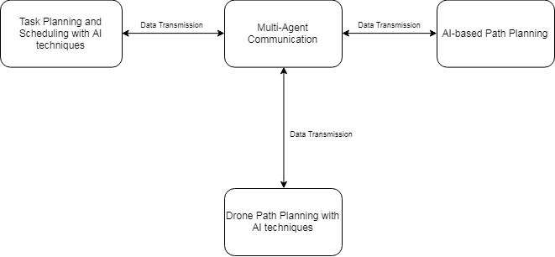
Figure 1: Context diagram for the general system

The context diagram in Figure 1 illustrates the relationships between each component of the general system. The Multi-Agent Communication system is the critical component because without it, there is no way for the other systems to communicate with each other. Task Planning and Scheduling with AI techniques System provides the initial data given to the Multi-Agent Communication System. The Multi-Agent Communication System transmits this data according to the content to either one of the path planning systems and the Multi-Agent Communication receives feedback from these systems and returns it back to the task planning system.

Product Functions
The features of the system are
- One-Way Communication
- Multi-Way Communication
- Broadcast Communication

These features will be explained in detail in Section 4.

User Classes and Characteristics
Agent | An Agent is tasked with certain duties. Each agent is expected to complete these duties and report back to the coordinator.
Coordinator | A coordinator is also an agent inheriting the attributes of an agent. Aside those attributes, it can broadcast data which ordinary agents are not allowed to do.

Operating Environment
System shall run on computer platforms. Operating systems, the system can operate on is
- Ubuntu 18.04

Design and Implementation Constraints
The system shall be implemented in Python 3.7. Frameworks that are used in multi-agent systems can be used depending on the licensing they use. Details of the framework that will be used are to be determined and explained in the design phase of the project. There are no time or memory constraints as of now.

User Documentation
No user documentation is available at this time.

Assumptions and Dependencies
It is assumed that the other systems that may use Multi-Agent Communication 1.0 are also implemented in Python 3.7. It is also assumed that the user has Ubuntu 18.04. It is assumed that the frameworks this system will use have no major bugs.

External Interface Requirements

User Interfaces
UI-1: To show the communication between the agents the user shall be provided with a
screen layout that resembles a messaging chat box.
UI-2: The system shall provide the information being transmitted on the screen.
UI-3: The system shall prompt the user to send the message again if the transmission was not successful.
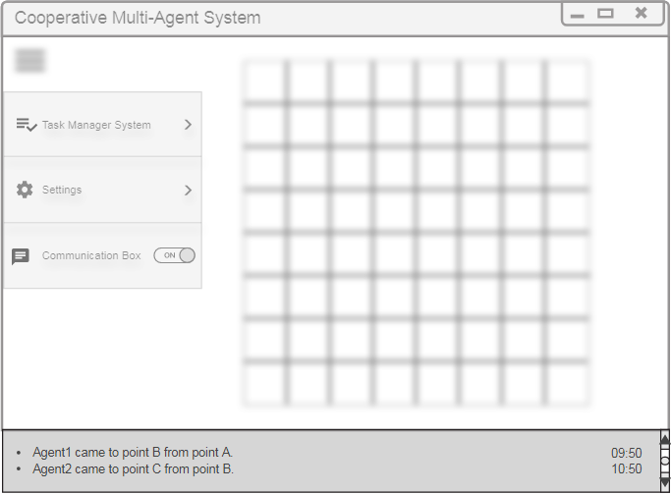

Figure 2: Mockup for the general user interface with the message box below the layout

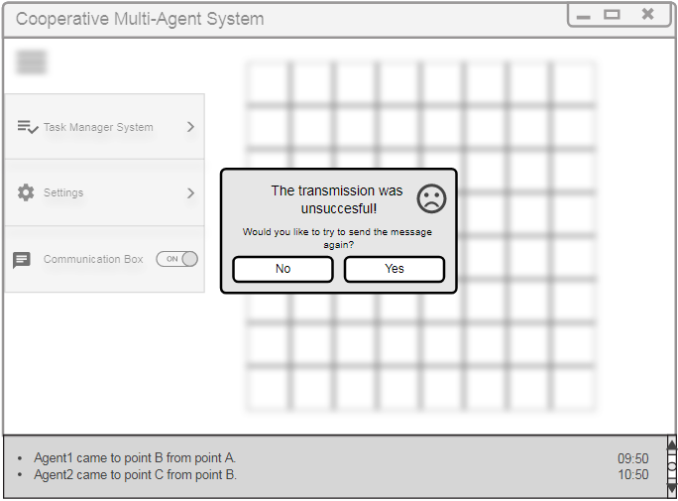
Figure 3: Mockup for the general user interface with unsuccessful message prompt

Hardware Interfaces
HI-1: Keyboard
HI-2: Screen
HI-3: Mouse

Software Interfaces
SI-1: The operating system shall be Ubuntu 18.04.
SI-2: The Integrated Development Environment (IDE) shall be PyCharm.

More software interface requirements are to be determined such as frameworks, libraries or tools in the development phase of the project.

Communications Interfaces
CI-1: The system shall follow a publisher/subscriber method since it will be asynchronous.
CI-2: The system shall acquire coordination information from the task manager system.
CI-3: The system shall direct the coordination information to the drone path planning system.
CI-4: The system shall acquire the information about the task needed on that coordination from the drone path planning system.
CI-5: The system shall direct the task information to the task manager system.
CI-6: If there is no route or the drone has low battery, the system shall acquire the information that the task of the drone is not completed.
CI-7: The system shall direct the state of the success of the task to the task manager system.
CI-8: The system shall acquire the information of the coordinates, the type of task and the number and type of the agent/agents needed for the specified task from the task manager system.
CI-9: The system shall direct the information of the coordinates, the type of task and the number and type of the agent/agents needed for the specified task to the multi-agent path planning system.
CI-10: The system shall acquire the information of the task completion success from the multi-agent path planning system.
CI-11: The system shall direct the state of the success of the task to the task manager system.
CI-12: If the location is unknown, the location is wrong which means there is an obstacle on the location, the number of agents exceeded, the number of agents is insufficient, there is no path and there is collision, the system shall inform the task manager system of these exceptions.
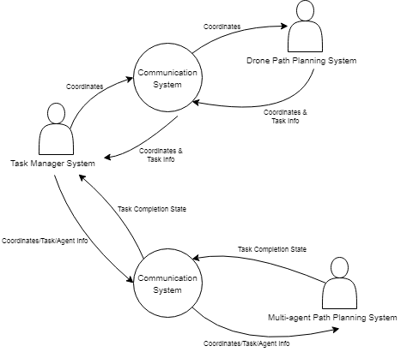

Figure 4: A simple diagram to summarize the communication requirements

System Features

One-Way Communication

Description and Priority
Agents shall have the ability to send and receive one-way messages. Each message shall particularly be received by a specified address and shall be sent to a specified address. The messages shall be ordered by the receiver agent according to the time the message was sent by the sender agent.
Priority: High

Stimulus/Response Sequences
Stimulus: Agent sends message to another agent.
Response: System retrieves the message and sends it to the address of the receiver.

Stimulus: Agent receives message.
Response: System retrieves the information of the state of the successfulness of the transmission.

Functional Requirements
REQ-1 | Send Message | The system shall retrieve the message and the specified address of the receiver from the agent and send it to the receiver according to the address indicated.
REQ-2 | Send Message Unsuccessful | The system shall check if the message is delivered to the receiver. If the delivery is unsuccessful, the system shall prompt the sender to send the message again.
REQ-3 | Receive Message | The system shall retrieve the information of the state of the successfulness of the transmission.

Multi-Way Communication

Description and Priority
Agents shall have the ability to send and receive multi-way messages. Each agent shall have the ability to request to join and leave a multi-way group. In each group the message shall only be sent to the group members. Each agent shall have the ability to be a member of many groups. Each agent shall have the ability to create a multi-way group. The initial creator of the group shall have the ability to set a time period for the group to stay active.
Priority: Low

Stimulus/Response Sequences
Stimulus: Agent creates group.
Response: System retrieves the address data of the members from the creator agent and stores the data.

Stimulus: Agent sets time for a group.
Response: System keeps the group active until the given time runs out.

Stimulus: Agent sends multi-way message.
Response: System directs the message to every member in the multi-way group.

Stimulus: Agent requests to join a group.
Response: System alerts the creator agent and asks whether to let the agent in the group or not.
Stimulus: Agent leaves a group.
Response: System removes the agent from the group.

Functional Requirements
REQ-1 | Create Group | The system shall create a group with the members specified by the creator agent.
REQ-2 | Send Message | The system shall allow every member of the group to send a multi-way message.
REQ-3 | Set Time Period | The system shall allow the creator of the group to set a time period for the group in which the system shall delete the group when the time runs out.
REQ-4 | Join Group | The system shall alert the creator that an agent wants to join the group.
REQ-5 | Leave Group | The system shall allow an agent to leave a multi-way group. The system shall remove the agent as a member

Broadcast Communication

Description and Priority
Coordinator agent shall have the ability to send broadcast messages. Other agents shall have the ability to receive broadcast messages. Broadcast messages shall be sent to all the available agents in the system.
Priority: High

Stimulus/Response Sequences
Stimulus: Coordinator sends broadcast message.
Response: System retrieves the message and forwards it to all the other agents in the system.

Functional Requirements
REQ-1 | Broadcast Message | The system shall allow the coordinator to broadcast a message to all the available agents.

Other Nonfunctional Requirements

Performance Requirements
PR-1: The system shall be responsive.
PR-2: The latency of the system shall be no more than xx (TBD).
PR-3: Memory requirements are to be determined in the design phase of the project.

Safety Requirements
No safety requirements have been identified.

Security Requirements
No security requirements have been identified.

Software Quality Attributes
Interoperability: The system shall be interoperable since it focuses on multi-agent communication.
Flexibility: The system shall be flexible so that it can interact with other systems.

Maintainability: The system shall be maintainable for later versions of the system.

Portability: The system shall be portable for different platforms such as Ubuntu
operating system.

Robustness: The system shall be robust as long as the input is correct.

Reusability: The system shall be reusable because many different systems may
need a communication system.

Testability: The system shall be testable with virtual devices in later phases of the
project.

Business Rules
No business rules have been identified.

Other Requirements
No other requirements have been identified.
Appendix A: Glossary
Term | Definition
SRS | Software Requirements Specifications
MAS | Multi-agent System
IEEE | Institute of Electrical and Electronics Engineers
AI | Artificial Intelligence
IDE | Integrated Development Environment

Appendix B: Analysis Models
No pertinent analysis models included.
Appendix C: To Be Determined List
- Design and Implementation Constraints
- Software Interfaces
- Performance Requirements

